**7 - JOINS**

**JOINS** ARE A MECHANISM TO COMPARE TWO OR MORE TABLES & COMBINE THE RESULT INTO A SINGLE TABLE OUTPUT. Ex: Product wise Sales. Ex: Database wise Backups

**PURPOSE** : WE USE JOINS MAINLY FOR AUDITS, DATA REPORTING & BUSINESS ANALYSIS.

**Syntax**: *SELECT <columnlist>* | *\* FROM*

***TABLE1 -- LEFT TABLE***

*<JOIN TYPE>*

***TABLE2 -- RIGHT TABLE***

***ON*** *<JOIN CONDITION>*

**TYPES OF JOINS:**

**1. INNER JOIN : USED TO COMPARE MULTIPLE TABLES, REPORT MATCHING DATA.**

**2. OUTER JOINS : USED TO COMPARE MULTIPLE TABLES, REPORT MATCHING & MISSING DATA 2.a - LEFT OUTER JOIN : All Left Table Data + Matching Right Table Data. Non match Right table data is reported as null.**

**2.b - RIGHT OUTER JOIN : All Right Table Data + Matching Left Table Data. Non match Left table data is reported as null.**

**2.c - FULL OUTER JOIN : Combined output of LEFT OUTER JOIN + RIGHT OUTER JOIN**

**3. CROSS JOIN :** USED TO REPORT ALL POSSIBLE COMBINATIONS OF DATA. NO COMPARISONS

EX: YEAR WISE, QUARTER WISE SALES [m X n : CARTESIAN PRODUCT]

**JOIN OPTIONS: USED FOR FASTER JOINS ::**

4. **MERGE JOIN** : USED TO JOIN DATA FROM **BIG** TABLES FOR FASTER JOINS BY AUTO SORTING

5. **LOOP JOIN** : USED TO JOIN DATA FROM **SMALL** TABLES FOR FASTER JOINS

6**. HASH JOIN** : USED TO JOIN DATA FROM ANY TABLES WITHOUT PRIMARY KEY [**HEAP TABLES**]

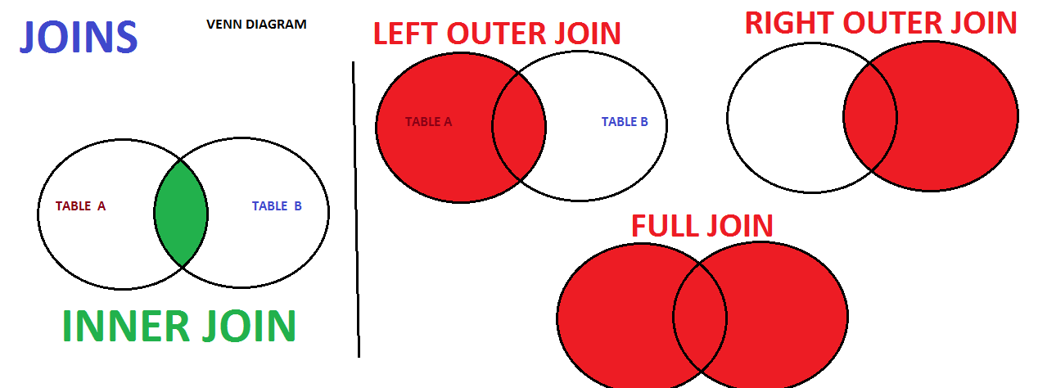

**PRACTICE EXAMPLES**

**REQ 1 : HOW TO REPORT ALL COURSES & RESPECTIVE STUDENTS IN EACH COURSE ?**

SELECT * FROM COURSES

INNER JOIN

tblStudents

ON tblStudents.StdCourse_ID = COURSES.COURSE_ID

**REQ 2 : HOW TO REPORT ALL COURSES WITH AND WITHOUT STUDENTS ?**

SELECT * FROM COURSES

LEFT OUTER JOIN

tblStudents

ON COURSES.COURSE_ID = tblStudents.StdCourse_ID

**REQ 3 : HOW TO REPORT ALL COURSES WITH AND WITHOUT STUDENTS ?**

SELECT * FROM tblStudents

RIGHT OUTER JOIN

COURSES

ON

COURSES.COURSE_ID = tblStudents.StdCourse_ID

**-- REQ 4 : HOW TO REPORT LIST OF ALL COURSES WITHOUT STUDENTS?**

SELECT * FROM COURSES

LEFT OUTER JOIN

tblStudents

ON

COURSES.COURSE_ID = tblStudents.StdCourse_ID

WHERE

tblStudents.StdCourse_ID IS NULL

**-- REQ 5 : HOW TO REPORT LIST OF ALL COURSES AND STUDENTS?**

SELECT * FROM COURSES CROSS JOIN tblStudents

SELECT * FROM COURSES CROSS APPLY tblStudents

**-- REQ 6 : HOW TO TUNE QUERIES WITH JOINS [FOR BIG TABLES] ?**

SELECT * FROM COURSES

INNER MERGE JOIN

tblStudents

ON COURSES.COURSE_ID = tblStudents.StdCourse_ID

**-- REQ 7 : HOW TO TUNE QUERIES WITH JOINS [FOR SMALL TABLES] ?**

SELECT * FROM COURSES

LEFT OUTER LOOP JOIN

tblStudents

ON COURSES.COURSE_ID = tblStudents.StdCourse_ID

**-- REQ 8 : HOW TO TUNE QUERIES WITH JOINS [FOR HEAP TABLES] ?**

SELECT * FROM COURSES

FULL OUTER LOOP JOIN

tblStudents

ON

COURSES.COURSE_ID = tblStudents.StdCourse_ID